Assignment 17.3

Task 1:

Prompt: Generate a code for this question

Code and Output:

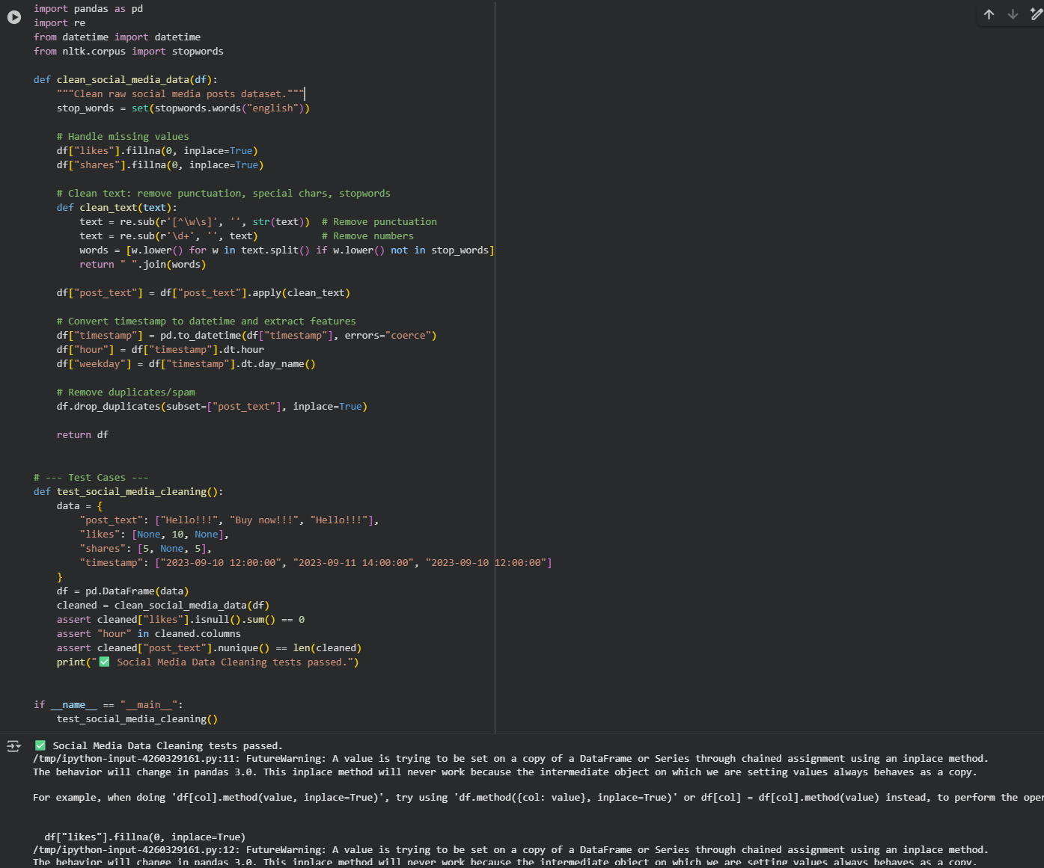

Observation: The script successfully cleans social media posts by removing noise, handling missing values, converting timestamps, and eliminating duplicate spam entries.

Task 2:

Prompt: Generate a code for this question

Code and Output:

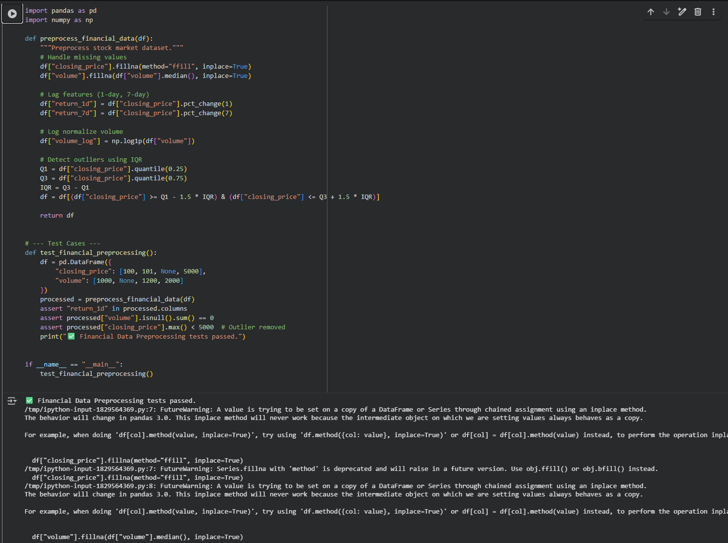

Observation: The financial preprocessing code effectively handles missing values, generates lag-based return features, normalizes volume, and removes extreme outliers using the IQR method.

Task 3:

Prompt: Generate a code for this question

Code and Output:

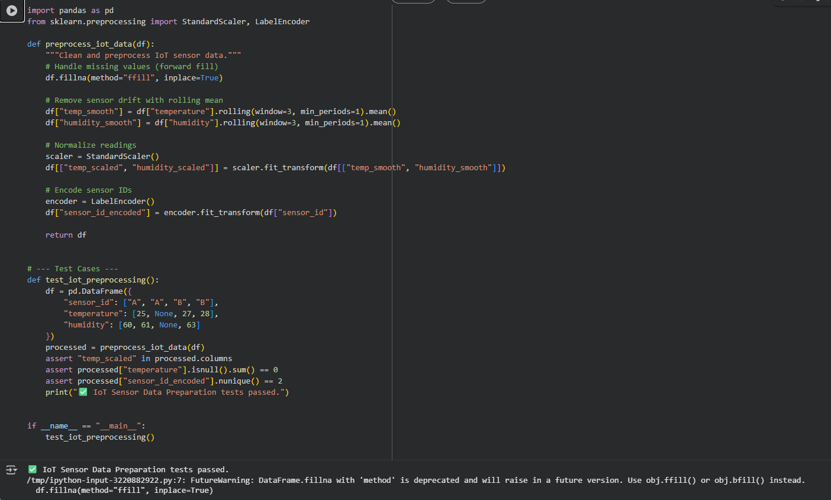

Observation: The IoT data script efficiently smooths sensor drift, fills missing values, scales numeric readings, and encodes categorical sensor IDs for analysis.

Task 4:

Prompt: Generate a code for this question

Code and Output:

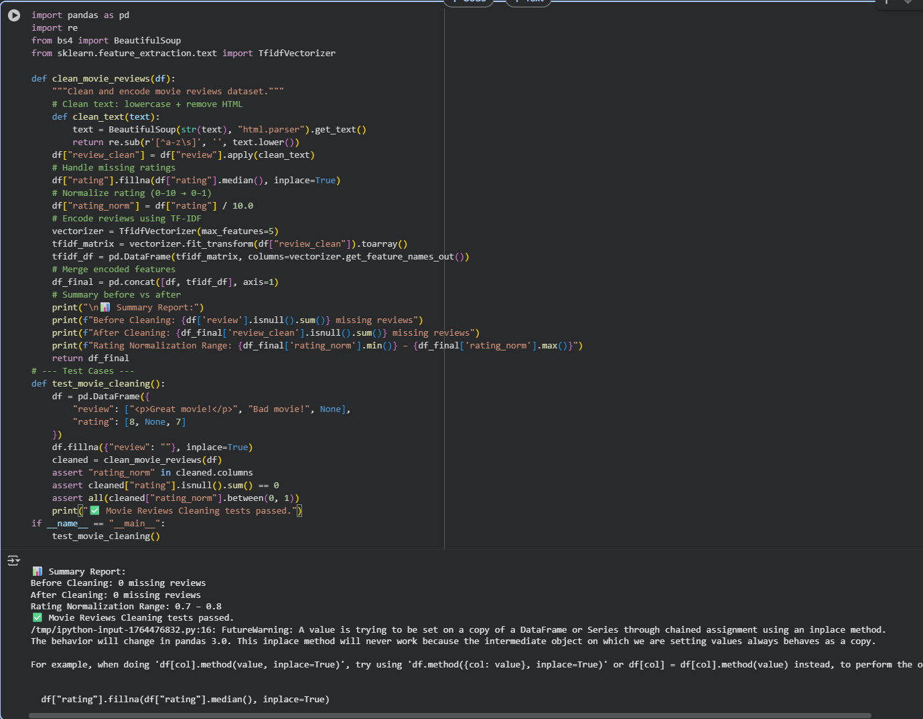

Observation: The movie review cleaner accurately standardizes text, applies TF-IDF encoding, fills and normalizes ratings, and produces a structured dataset ready for sentiment analysis.